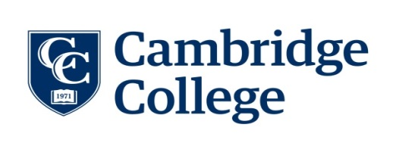

Instructions for the Institutional Review Board (IRB) Submission
According to 45 CFR 46, of the Code of Federal Regulations, The U.S. Department of Health and Human Services has mandated that research which involves human research participants must be approved by an Institutional Review Board (IRB) to ensure the safety and the appropriate use of humans as subjects in research studies. All protocols involving human subjects must be submitted to Cambridge College’s Institutional Review Board for exemption or approval. Cambridge College’s institutional policy does not permit self-exemption.
Based upon guidelines provided by the Department of Health and Human Services, the Institutional Review Board will either 1) exempt the protocol from formal review or require that it undergo either 2) an expedited review by a member of the IRB, or 3) review by the full committee during a convened meeting.
Before submitting your proposal to Cambridge College’s Institutional Review Board, please make sure you complete the following steps:
1. Complete Ethics Training.
All students and faculty who conduct research at Cambridge College must submit evidence that they have successfully completed the NIH web-based training course “Protecting Human Research Participants”.
Ongoing education in the ethical treatment of research participants, the components of informed consent, and the handling of research materials and data is an important component of research and scholarship. Training is available on-line through the National Institutes of Health at https://phrp.nihtraining.com/users/login.php and takes approximately two hours to complete.
Once you have successfully completed the online tutorial, make sure you print out 2 copies of the COMPLETION CERTIFICATE for your records. Please save an electronic copy of the completion certificate before you log off so that you can submit it to the IRB via email. This certificate is required to document that you completed the online course and will be filed with your approved consent form and other materials.
2. Complete all pieces of the application.
A complete application includes the IRB Protocol Approval Request, along with any additional relevant documents. Additional documents might include needed informed consent documents, surveys, recruitment letters or e-mails, and so forth. Keep in mind that the student’s Faculty Advisor must sign off on all student projects.
A properly completed protocol will include a brief rationale for the study, a full description of procedures, description of the participants, copies of all tests and questionnaires, all interview questions, the informed consent form, and other pertinent information. Your narrative should be written for a general audience so that anyone without a working knowledge of your field of research can understand what you are researching and how you plan to complete your research project.
3. Submit your project proposal.
Submit all required forms to the coordinator of the Cambridge College Institutional Research Board, Dr. Joseph Miglio, at (617) 873-0490 or joseph.miglio@cambridgecollege.edu. Normal review times are three to four weeks for an expedited review, and more than one month for a full review, provided all the necessary information has been included in the submission.
Please note: Following the initial submission of your protocol, you may be asked to make some revisions before your project will be reviewed. If these pre-review revisions are not made and submitted within 60 days, your project will be withdrawn and must be re-submitted as a new project. Please allow sufficient time (3-4 weeks) for review; and, if necessary, additional time to correct and submit for approval any revisions required by the IRB committee to the protocol.

