New Treasures

Executive Summary
New Treasures (NT) is a start-up antique retail establishment soon to be located in Western Massachusetts. NT expects to catch the interest of a regular loyal customer base with its dedication to providing a curated and polished inventory of antique furniture and iconic period pieces. The company plans to build a strong market position in the area, due to the owner’s industry and sales experience by taking advantage of the weakly digitally marketed competitive climate in the area. NT aims to offer its products at a competitive price to meet the demand of middle-to higher-income local market area residents and tourists.

The Company
NT intends to be an LLC incorporated in the state of Massachusetts and located in Cheshire. It will be solely owned by Polly Lakeshire. Polly has extensive experience in sales, customer service and management and was a sales manager for a Hospitality Group along with a sales/office manager for a hot fudge company. The company intends on having Polly’s partner assist with staffing the store on a volunteer basis.

Products and Services
NT intends to offer a broad range of antique products and services aimed at both antique enthusiasts along with antique dealers.

Antique dealers will be able to lease space from NT to advertise their own products at an acceptable rate for Berkshire County Area. Their products will be advertised along side products obtained by NT directly to help facilitate a symbiotic retail experience for all parties involved.

Antique enthusiasts will be exposed to products that have been curated and selected for their iconic nature and overall quality. The store and its products will be displayed in a way to allows patrons to truly appreciate and admire each piece. Polly will share her expertise regarding the pieces displayed along with their history, maintenance and functionality. Polly will also be offering her services regarding finding unique pieces that have a personal connection to the patron.

The Market
The retail antique market has remained overall consistent over the years, especially regarding furniture. The demand for quality furniture and home decor pieces has remained strong as the market continues to be imbued with cheap, low quality pieces. In addition, the western Massachusetts area and New England in large has an existing reputation as being a go-to location for antique shopping.

NT wants to establish a large regular customer base, and will therefore concentrate is business and marketing on local residents, which will be the dominant target market. This will establish a healthy, consistent revenue base to ensure stability of the business. In addition, tourist traffic is expected to comprise a notable amount of the revenues due to the high visibility on a state highway along with the proximity to major cultural destinations.

Financial Considerations
NT has raised $17,000 of its own capital, and seeks to borrow $68,000 through a 25 year loan to purchase the property along with a $12,000 business loan to cover start-up costs and improvements to the building. This provides the bulk of the current financing required.

NT anticipates sales & rental income of about $24,280 in the first year, $35,710 in the second year, and $37,638 in the third year.

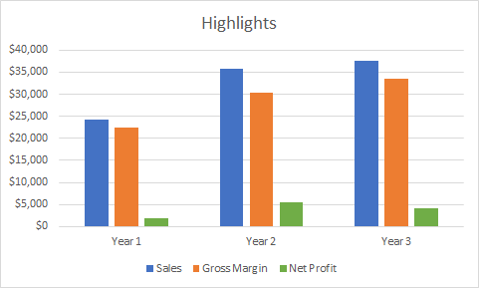

General Description of the Business: A retail store that sells antique furniture and relics from the past. Vender space will also be rented out to other antiques dealers to sell their own products. The owner will Polly Lakeshire, New Pleasures to be located at 100 Escape Street, Cheshire, Massachusetts. The legal entity for the business will be an LLC.

MISSION: New Pleasures’ mission is to share an appreciation of relics from our communal past

SHORT TERM GOAL 1: Sales Goal - Fulfill sales projections from the business plan of $11,200 by year 1
OBJECTIVE A: Monthly Gross Sales for Jan-April of $700
OBJECTIVE B: Monthly Gross Sales for May-August of $900
OBJECTIVE C: Monthly Gross Sales for Sept-Dec of $1200

SHORT TERM GOAL 2: Rental Goal - Rent all of the available vender space
OBJECTIVE A: 1 vender at store opening
OBJECTIVE B: 4 venders at end of 1st year
OBJECTIVE C: Fully rented at 18 months (assuming 6 available spaces)

SHORT TERM GOAL 3:Operations Goal - Efficient Inventory Control
OBJECTIVE A: Create and Utilize an item code system to record expenses of each item acquired
OBJECTIVE B: Monitor sales based on general categories of goods on a quarterly basis to assess and adjust to market trends
OBJECTIVE C: Develop and utilize an efficient system of maintaining online inventory vs store inventory

LONG TERM GOAL 4: Achieve a comfortable Owner’s Draw for personal expenses
OBJECTIVE A: $7,200 at end of Year 2 (Half of home mortgage)
OBJECTIVE B: $22,880 at end of Year 5 (Min wage - $12.50 per hour)
OBJECTIVE C: $31,200 at end of Year 10 ($15 per hour - Livable wage in 2022)

Background Information
- Industry Overview:
Western Massachusetts has a unique connection to the antique business as this region has some of the longest history dating back before the creation of the United States in combination with a general appreciation and preservation of relics from the past. Unlike parts of Connecticut and New York that tend to cast aside the past for what is new and fresh, western Massachusetts has a greater appreciation for our collective history. As a result, many of the objects from our past have been preserved over the years. As the baby boomers continue to enter retirement, more and more people are in the process of downsizing and relics that they have from this youth or have inherited from their family will continue to enter the market and the supply of quality antiques will continue to exist for the foreseeable future.

In regards to demand from customers for antiques there exists subsections of the general public who appreciate the craftsmanship of products from yesteryear over the mass-produced items of today with their inherent obsolescence built into their cheap quality. As younger generations who have been dependent on cheaper products out of necessity age and enter into home-ownership they will start to focus their financial resources into more sustainable products. Some will obviously be drawn to higher quality new products in order to follow the ever-changing trends. Yet others who are drawn to the aesthetic of antiques will start to fill their homes with pieces that have survived the ravages of time. To put it simply, an IKEA piece of furniture will be lucky to survive its initial assembled in comparison to handcrafted furniture from over 100 years ago.

In addition, local residents tend to be more inclined to decorate their homes with pieces that match the vintage of the homes themselves. With the average age of the homes in the area being close to 100 years old there is more desire for authentic period pieces.

Pop culture has also sparked a resurgence of popularity in antiques. A great example being the tv series Mad Men. During the peak of the shows performance, the demand for 1960’s pieces depicted in the show jumped in popularity. That demand has faded as a result of the show ending yet certain pieces from that era are still sought after in higher demand than before.

The same can be said for the resurgence of vinyl. Even with superior audio technology in existence, many appreciate the unique sound from vinyl records that cannot be duplicated with MP3s. This appeal comes from both the generations of adults who grew up with vinyl and have continued to pursue that interest throughout their lives along with younger generations who want to experience the music in the way in which is was originally created.

All in all the demand for antiques continues to be strong. There is the ebb and flow in regards to tastes but the quality of most antiques are far superior to their modern counterparts. This can be seen in the lack of availability in area antiques store for additional vender space. Customers that are drawn to an older aesthetic will continue to fuel the desire for antiques for years to come.

- Business Fit - The business will act as a conduit between the general inventory of antiques from auction houses and private acquisitions to customers who are interested and passionate about these products but do not have the time, inclination or knowledge to acquire antiques directly. New Pleasures is following in the example of other successful companies and learning from the successes and faults that each of them possess.

The Marketing Plan
- Products: Antiques of both domestic and foreign origin dating from the colonial era to the recent past with particular focus on pieces from the 1950’s or older due to their better quality and rarity.
- Services:
  - Customers - If a customer is looking for a difficult to find piece, the owner can document what the customer is looking for along with their desired price range to purchase the item. During his normal trips to area auction houses if the desired piece is found the customer will be contacted to ensure that the piece is correct and that they are still interested in the purchase. The piece will then be sold to the customer.
  - Antique Dealers - Space will be made available for rental for existing antique dealers who do not currently possess their owner retail space. New Pleasures will provide space to display their pieces, facilitate all sales, facilitate the associated sales tax, provide overall customer service and provide advertising to the store which will expose the dealers products to more potential customers.
- Benefits to the customer - The overall quality and presentation of the items for sale will be more inviting and enticing for customers. Antique stores in general tend to be very over crowded, dirty, and overwhelming, along with including a lot of generally poor/broken products. New Pleasures intends to create a more inviting space and to have each of the products displayed at their best so that customers can see their true value and beauty and envision the product in their home.
- Seasonality - Sales are anticipated to peak in the later end of the year (September - December) coinciding with both higher tourism in the fall months throughout western Massachusetts and the holiday season. This will be contrasted with weaker sales in the early part of the year (January - April) due to poor weather and less disposable income of Americans due to the holiday rush. The summer months (May - August) will have average sales as the weather will no longer hinder general foot traffic to the store and the average consumer will have financially recovered from the holidays by this point.
- Growth potential - An existing antique store started their business in town 10 years ago. The building they rented was in rougher condition than 100 Escape Street yet their business grew over several years to the point that they were able to move to a location on Main Street Pittsfield with more than triple the amount of retail space. Not only was the customer base for antiques strong enough to allow for the growth, there also exists a healthy supply of antique venders looking for rental space to sell their goods. This particular store currently has a one year wait time for open rental space for dealers. A second store, based out of Williamstown, was able to fill 37 spaces since opening in October 2017. The building itself has additional floor space that is currently being rented that can nearly double the retail space if and when needed.
- Customer Demographics - Men & Women in their late twenties to their early fifties. Homeowners or those who have an established residence. Moderate to high income households that allow for a healthy amount of disposable income. Area residents from Berkshire, Franklin and Hampshire Counties along with transient visitors from CT, NY and Vt. Those who appreciate history and/or quality craftsmanship.
- Competitor’s strengths and weaknesses:
Super Cool Stuff, Pittsfield, MA
Strengths:
  - Established business
  - High traffic location
  - Large amount of retail space
  - Open daily
Weaknesses:
  - Outdated website
  - No ecommerce capabilities
  - Inconsistent address information among multiple sites
  - Incomplete profile on Tripadvisor
  - Basement level uninviting due to moldy/mildew smell
  - No dedicated parking

Second Chance, Williamstown, MA
Strengths:
  - Established Business
  - High traffic location
Weaknesses:
  - Outdated website
  - Multiple conflicting websites
  - Small retail space
  - Very overcrowded - Difficult to walk through store

Arts and Antiques Charlemont, MA
Strengths:
  - High traffic location
  - Established business
  - Dedicated parking
  - Large retail space
  - Diversified products
  - Consistent FaceBook updates
  - Open daily
Weaknesses:
  - Unpolished website
  - No TripAdvisor presence
  - Less of a focus on antiques

Old Things Antiques
Strengths
  - High traffic location
Weaknesses:
  - Outdated & incomplete website
  - No social media presence
  - No 3rd party site presence (Tripadvisor, Yelp, Google Business)
  - Unknown hours of business
  - Poor reputation from past management of property
- Market potential (2016 Census Data):
  - Franklin County MA - Total population of 70,916, 69% home ownership, 55% of households earn more than 50k a year, 38% of residents between the ages of 25-54, $60 million received through local tourism
  - Hampshire County MA - Total population of 161,035, 66% home ownership, 59% of households earn more than 50k a year, 33% of residents between the ages of 25-54, $132 million received through local tourism
  - Windham County MA - Total population of 43,609, 68% home ownership, 51% of households earn more than 50k a year, 36% of residents between the ages of 25-54, $126 million received through local tourism
- Marketing strategy:
  - Signage outside of the building that simply and immediately conveys that New Pleasures is an antique retail store
  - A-Frame style sign outside of the building that simply and immediately conveys that the store is currently open
  - Google AdWords campaign geared towards attracting tourists who are visiting the area or passing through the area to visit the store or purchase items from the website
  - Active social media presence on Facebook, Twitter & Instagram to keep customers up to date on new products available
  - Creating and maintaining 3rd party sites (Tripadvisor, Yelp, Google Business) regarding business hours and responding to reviews of the business
  - Membership to Business Network International (BNI), Chamber of Commerce & Franklin County Young Professionals in order to develop reciprocating relationships with accessory businesses
  - Print advertising at local hotels, chambers of commerce and tourist center.

- Price/quality relationship:
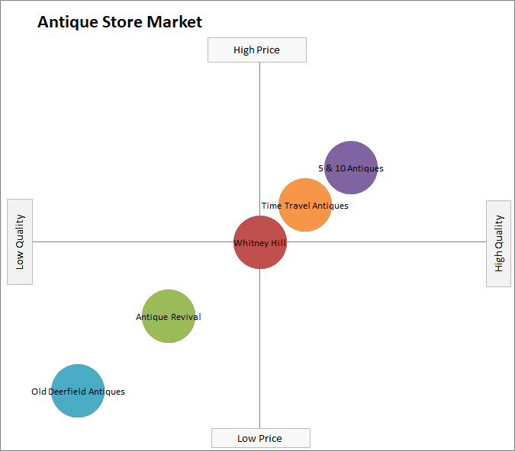
- Promotional strategies:
  - Branded Products - Reusable shopping bags with NT logo
  - Social Media - In depth history of newly acquired products will be shared on social media. The posts will be more educationally focused will still showing new products that have been acquired
  - Gift Card Contest - Promote on Facebook that everyone who Likes the Facebook page within a certain time period (a week or so) is eligible to win a gift card to the store
- Packaging plan:
  - Business cards with company logo
  - Flyers for distribution at local hotels & tourist sites
  - A-Frame sign outside of business
  - Reusable shopping bags with logo

Operating Controls
- Legal Identity - LLC
- Cash Management - cash basis for tracking accounts receivables, and accounts payables. Polly Lakeshire, as the sole owner, will be responsible for handling sales receipts, reconciliation of bank accounts and petty cash. Polly Lakeshire, the owner’s husband, will assist on a needed basis when the owner is attending area auctions that coincide with normal business hours.
- Utilizing Polly Lakeshire’s three years of private antiques sales she will solely be responsible for internal management procedures related to purchasing, inventory control, pricing, and quality control.
- Utilizing Polly Lakeshire’s 10 years of customer service experience she will primarily be responsible for managing the procedures regarding customer service.
- Pricing will be determined on an item by item basis in order to ensure a minimum of a 40% markup using a combination of personal experience and online research into more exotic products. Each products acquisition cost will be document in order to allow for discounts/negotiations while ensuring that profits are maintained
- Quality control procedures - All of the products displayed for sale will be in a presentable state. This will be defined as clean, in proper working order if so advertised and displayed in a fashion that will allow the customer to appreciate the piece. New Treasures will create an inviting atmosphere that contradicts the excessive clutter, dirtiness and moldy odor that is common with antique shops. Lessees will be screened to ensure that their products comply with this established practice to ensure an overall cohesiveness regarding the presentation and quality of each product.
Customer service will be paramount to ensuring that each potential patron has a positive experience during their visit, whether or not a purchase is made. Each customer will be greeted upon entry to the store. Any questions regarding the specifics of any of the products will be answered with as much detail as is available. Functioning products (records players, clocks, movie projectors, lamps, etc) will be demonstrated to the customer upon request to ensure its functionality along with teaching the customer proper usage and maintenance if desired. The fundamental goal regarding customer service is to make sure that every customer is satisfied with their experience visiting New Pleasures and that any products that they purchase meets their expectations regarding condition.
- Advisory Team:
Attorney – Red Woodpecker, Attorney at Law
CPA – Blue Jay
Insurance Agent – Morning Dove, Sales Executive, Independent Insurance
Business Consultant – Cardinal Counseling, CDC
Marketing – Stewart Success, Freelance Marketing Consultant

The Financial Plan
- See Attached

Environmental Sustainability
- A fundamental component of environmental sustainability that is incorporated in the day to day workings of New Pleasures is the reduction of items that would be sent to a landfill. All of the inventory consists of used products that are no longer needed by their former owners. Instead of said products being thrown in the trash, they are acquired through auctions and private sales and resold to interested buyers. This helps reduce the overall impact on the environment and help mitigate the growth of area landfills.
- Products that are damaged beyond repair or use will have their components recycled and disposed of in the most environmentally friendly way as possible.
- Inventory will be sourced from area auction houses and residents which will continue the existing ecosystem of minimizing waste and extending the life of usable products, reducing our need to harvest resources to recreate products that are readily available.

Feasibility Action Statement
- Inventory - Products have been and continue to be acquired in recent weeks in order to have a healthy initial inventory for when the business opens
- Local Government - The Town of Cheshire has been contacted to ensure the use of the building complies with local zoning regulations. Upon speaking with local officials, the current use of the building as a retail plumbing showroom would warrant little resistance for the building’s use to become a retail antique store. A formal application has been submitted and awaits review.
- Marketing - Multiple components of the marketing plan are underway with the assistance of a marketing consultant. These include the development of a website, creation of a logo, designing the signage for the building, online advertising using Google AdWords & Google Analytics & social media development/promotion.
- Building Improvements - Upon completion of the purchase of the building, the existing office area will be updated to facilitate rental of the space. These repairs will include sealing off the unused ductwork from the forced hot air system, installing a dedicated heating/cooling unit for the rental, installing a door to secure the rental space from the antique store, wiring the space for separate phone/internet service, installing a drop ceiling to match the renovated retail space and a fresh coat of paint.
- Rentals - Upon completion of the purchase of the building both the office space and the antique vender space will be advertised in order to fill the vacancies. The goal is to secure at least 1 of the 6 antique vender spaces prior to the opening of the business.

